CSC108 – Introduction to Programming

Lab07:

**Students Grades:**

Create a Java application in NetBeans called “Lab07” that prompts the user to enter a length of an array, and then prompts the user to enter that number of scores. The program then prints the scores, the lowest, highest, average, number of A’s, B’s C’s, D’s, F’s, and then prints the scores in descending order. Use the following method headers:

// print scores

public static void printScores(int[] array)

// lowest score

public static int lowestScore(int[] array)

// highest score

public static int highestScore(int[] array)

// average score

public static double averageScore(int[] array)

// count grades

public static int countGrades(int[] array, char gradeType)

// print descending scores

public static void printDescendingScores(int[] array)

Sample Java output:

Enter the length of the array:

5

Enter 5 scores:

65 78 75 98 87

Printed scores: 65 78 75 98 87

Low: 65

High: 98

Avg: 80.6

A's: 1

B's: 1

C's: 2

D's: 1

F's: 0

Scores in descending order: 98 87 78 75 65

Zip the Lab07 folder and send it to me as an attachment in Blackboard.

**Flowchart Methods:**

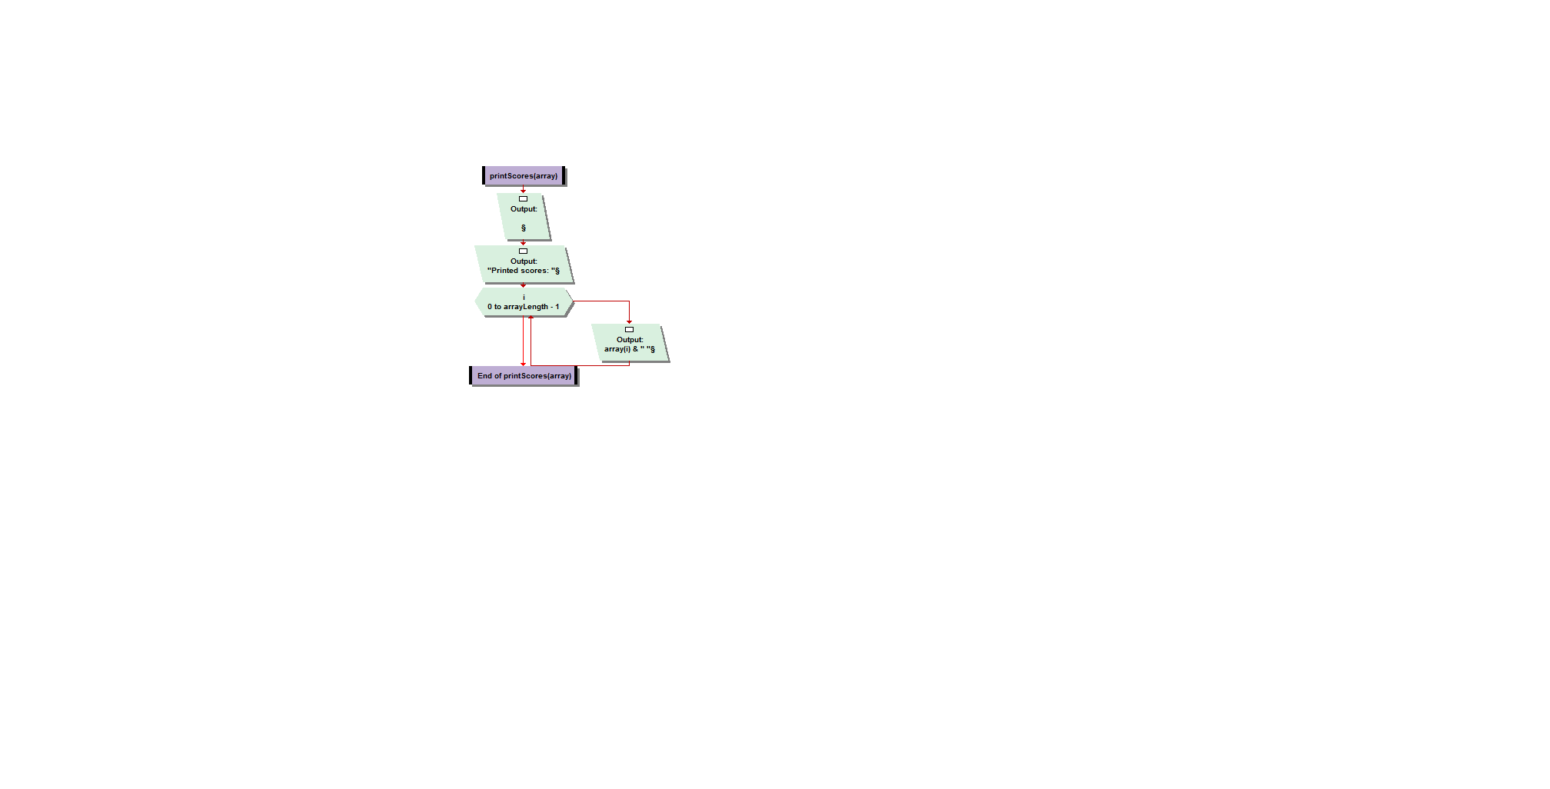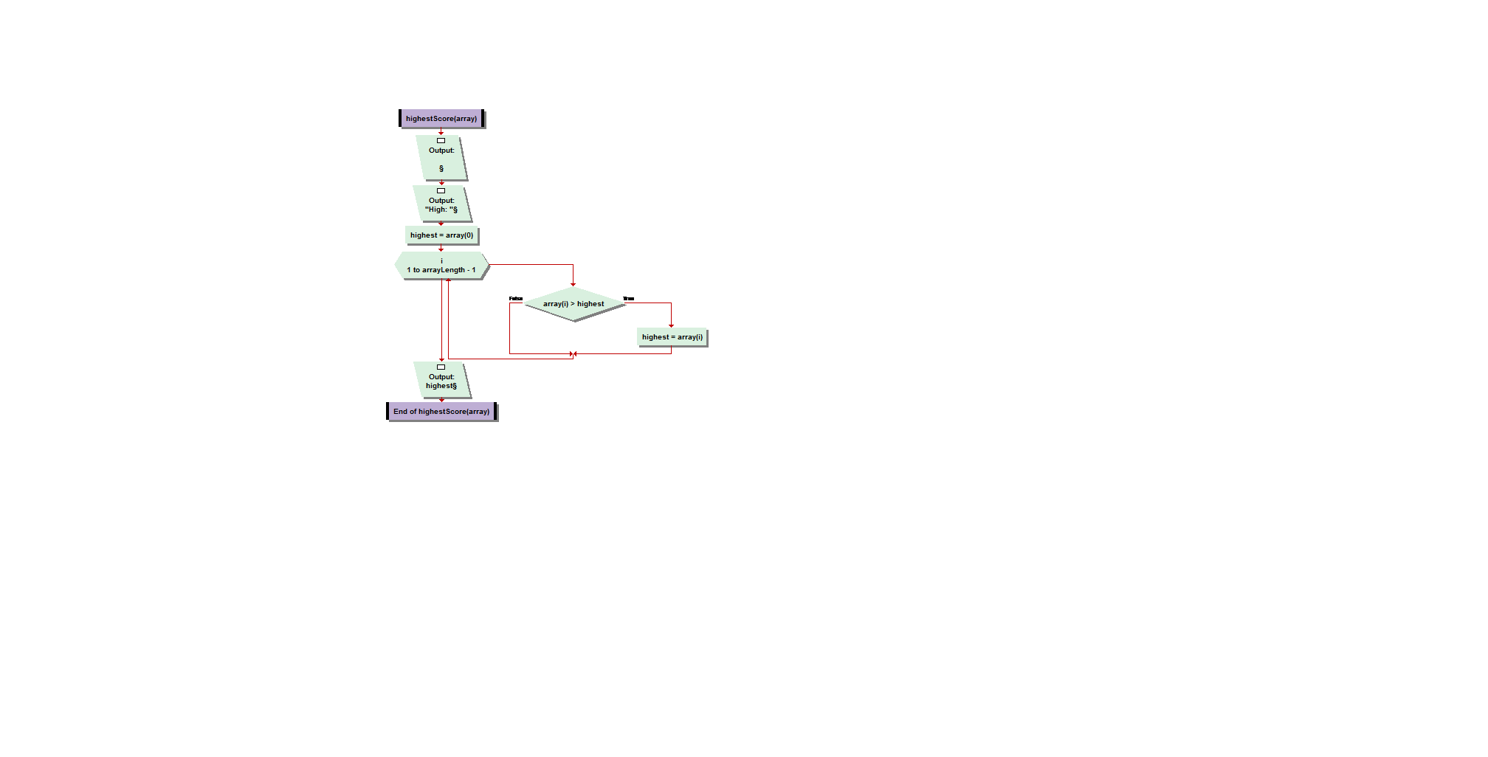

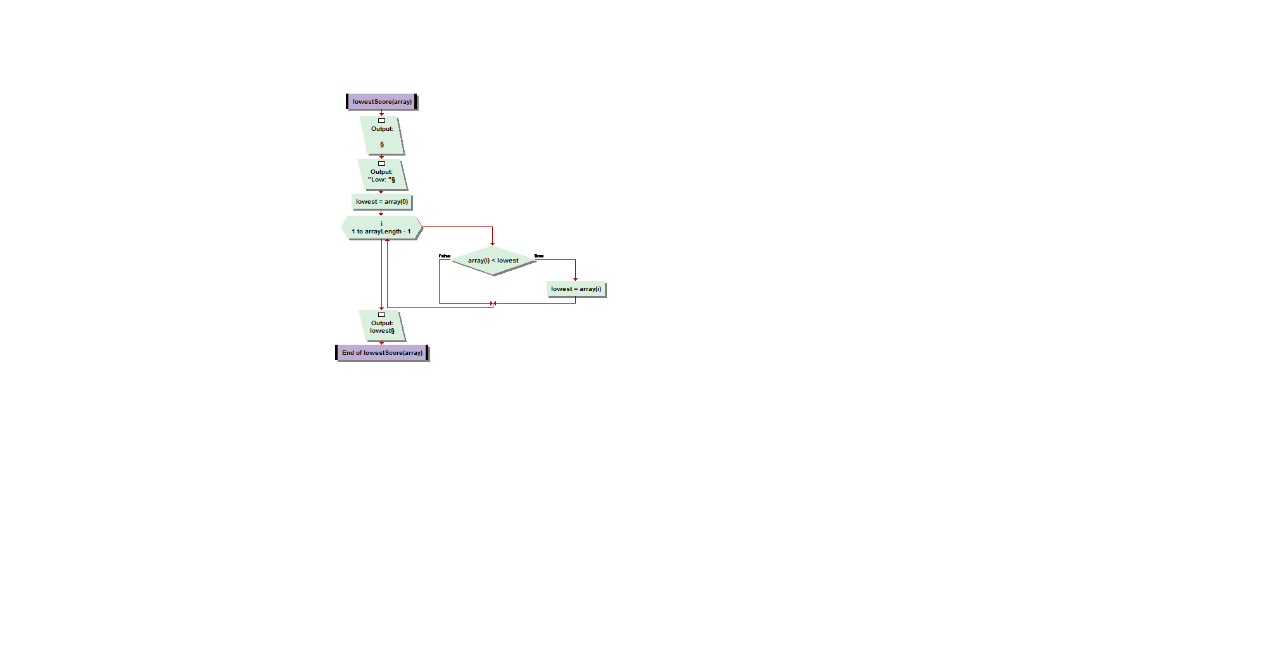 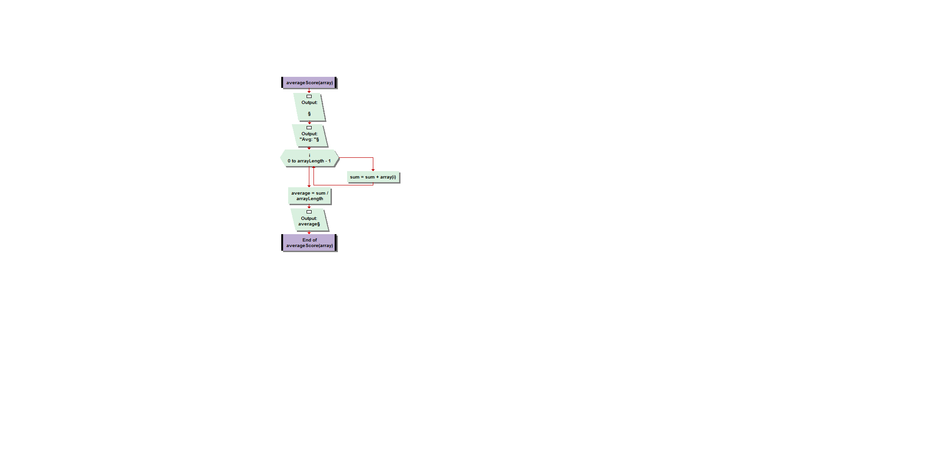

**main:**

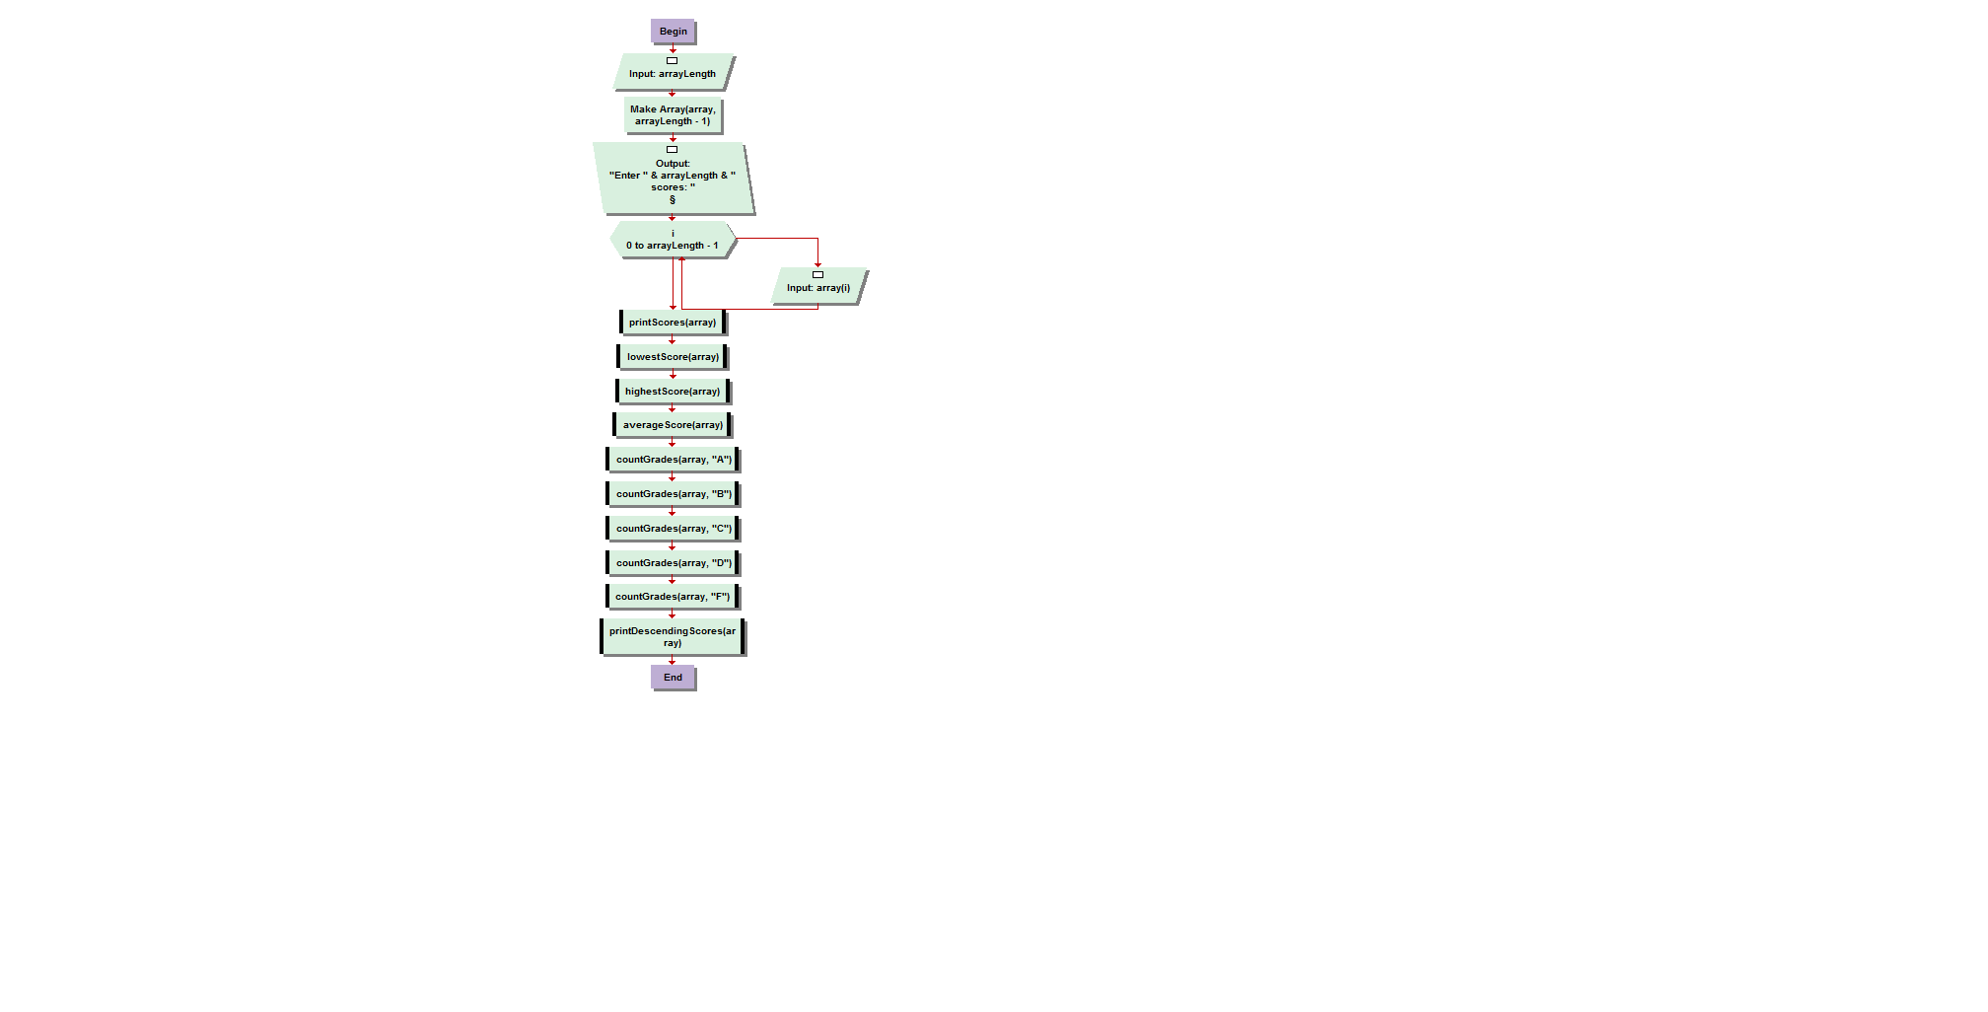

**(Use a “switch” statement in Java for the countGrades flowchart below)**

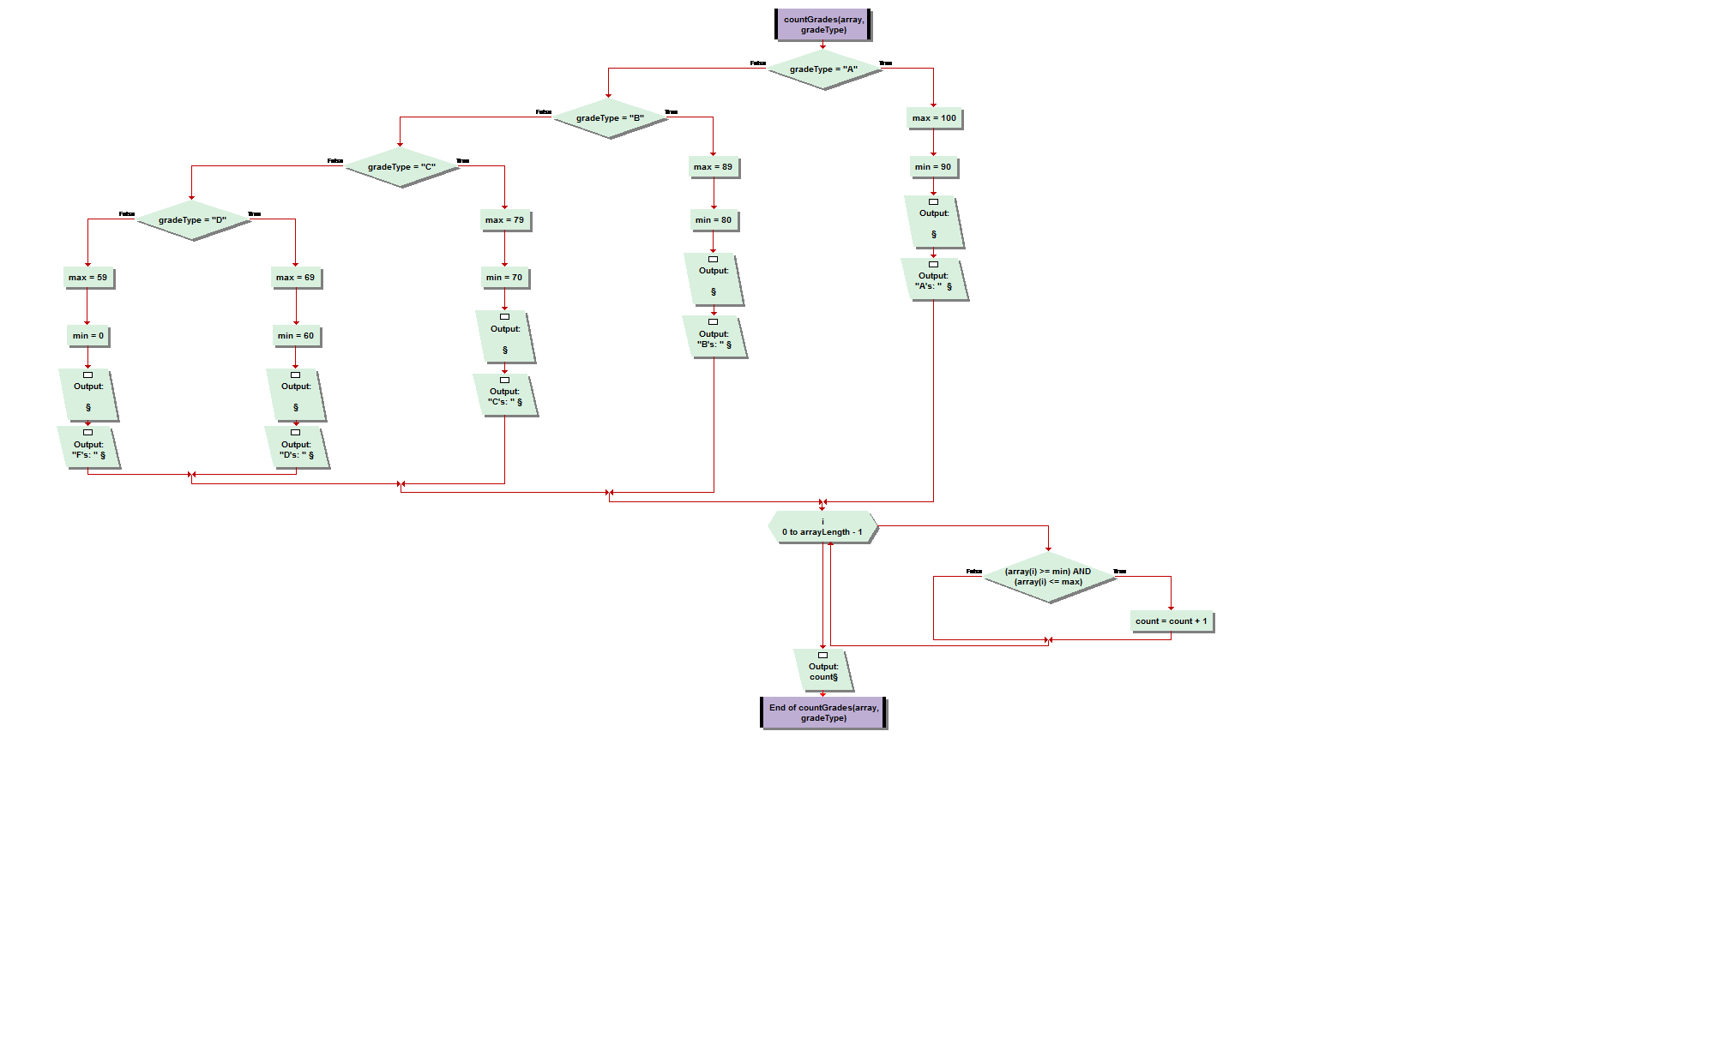

**printDescendingScores algorithm:**

**1. Call java.util.Arrays.sort method. Pass it the array of scores.**

**2. The array will then be sorted in ascending order.**

**3. Print "Scores in descending order are: ".**

**4. Using a “for” loop, point to the end of the array, and traverse the array backwards, printing each score.**

**public class Test28 {**

**/\*\***

**\* @param args**

**\*/**

**public static void main(String[] args) {**

**// TODO Auto-generated method stub**

**System.out.println("Enter the length of an array");**

**int length = in.nextInt();**

**int arr[] = new int[length];**

**System.out.println("Enter "+length+" scores :");**

**for(int i=0; i<length; i++){**

**arr[i] = in.nextInt();**

**}**

**printScores(arr);**

**int min = lowestScore(arr);**

**System.out.print("Low: "+min);**

**System.out.println("");**

**int max = highestScore(arr);**

**System.out.print("High: "+max);**

**System.out.println("");**

**double avg = averageScore(arr);**

**System.out.print("Avg: "+avg);**

**System.out.println("");**

**char c[] = {'A', 'B', 'C', 'D', 'F'};**

**int count = 0;**

**for(int i=0; i<c.length; i++){**

**count = 0;**

**count = countGrades(arr, c[i]);**

**System.out.println(c[i]+"'s: "+count);**

**}**

**printDescendingScores(arr);**

**}**

**// print scores**

**public static void printScores(int[] array){**

**System.out.print("Printed Scores : ");**

**for(int i=0; i<array.length; i++){**

**System.out.print(array[i] +" ");**

**}**

**System.out.println("");**

**}**

**//lowest score**

**public static int lowestScore(int[] array){**

**int min = array[0];**

**for(int i=1; i<array.length; i++){**

**if(min > array[i])**

**min = array[i];**

**}**

**return min;**

**}**

**//highest score**

**public static int highestScore(int[] array){**

**int max = array[0];**

**for(int i=1; i<array.length; i++){**

**if(max < array[i])**

**max = array[i];**

**}**

**return max;**

**}**

**//average score**

**public static double averageScore(int[] array){**

**int sum = 0;**

**for(int i=0; i<array.length; i++){**

**sum = sum + array[i];**

**}**

**return ((double)sum/array.length);**

**}**

**//count grades**

**public static int countGrades(int[] array, char gradeType){**

**int count = 0;**

**for(int i=0; i<array.length; i++){**

**if(array[i] <= 100 && array[i] >= 90 && gradeType == 'A')**

**count++;**

**else if(array[i] < 90 && array[i] >= 80 && gradeType == 'B')**

**count++;**

**else if(array[i] < 80 && array[i] >= 70 && gradeType == 'C')**

**count++;**

**else if(array[i] < 70 && array[i] >= 60 && gradeType == 'D')**

**count++;**

**else if(array[i] < 60 && gradeType == 'E')**

**count++;**

**}**

**return count;**

**}**

**//print descending scores**

**public static void printDescendingScores(int[] array){**

**int temp = 0;**

**for (int i = 0; i < array.length; i++)**

**{**

**for (int j = i + 1; j < array.length; j++)**

**{**

**if (array[i] < array[j])**

**{**

**temp = array[i];**

**array[i] = array[j];**

**array[j] = temp;**

**}**

**}**

**}**

**System.out.print("Scores in descending order: ");**

**for (int i = 0; i < array.length; i++)**

**{**

**System.out.print(array[i] + " ");**

**}**

**}**

**}**

**Output:**

**Enter the length of an array**

**5**

**Enter 5 scores :**

**65 78 75 98 87**

**Printed Scores : 65 78 75 98 87**

**Low: 65**

**High: 98**

**Avg: 80.6**

**A's: 1**

**B's: 1**

**C's: 2**

**D's: 1**

**F's: 0**

**Scores in descending order: 98 87 78 75 65**